WEEK 4
Week Ending: 26-09-2025 |  | DAY: |  | Subject: COMPUTING
Duration: 50mins |  |  |  | Strand: Introduction to computing
Class: B7 |  | Class Size: |  | Sub Strand: Computer Systems
Content Standard:  B7.1.1.2. Demonstrate the use of the features of the Windows Desktop |  |  | Indicator:  B7.1.1.2.1 Discover the latest Windows Operating System (Start screen, Use of tiles, Taskbar buttons, Preview thumbnails), temporal peeking into a window on a taskbar |  |  | Lesson:  1 of 1
Performance Indicator:  Learners can explain the meaning of operating system, identify the latest and describe the features of a taskbar |  |  |  |  | Core Competencies:  Communication and Collaboration, Critical Thinking and Problem solving
References: Computing Curriculum Pg.
Keywords: Operating System (OS), Taskbar, Windows, Preview, Version
Phase/Duration | Learners Activities |  |  |  |  |  | Resources
PHASE 1: STARTER | brainstorm learners if they know what an operating system is and if they can name any. Write their responses on the board.  Show the Windows logo and ask learners if they recognize it and what it is associated with.  Briefly discuss that Windows is an operating system used by many computers around the world.
PHASE 2: NEW LEARNING | Introduce the concept of the Windows Operating System, explaining that it is software that manages computer hardware and software resources and provides common services for computer programs.  Provide examples of different versions of Windows, such as Windows 7, Windows 8, Windows 10, and the latest version, Windows 11.  Show screenshots of each version to illustrate the differences and improvements over time.  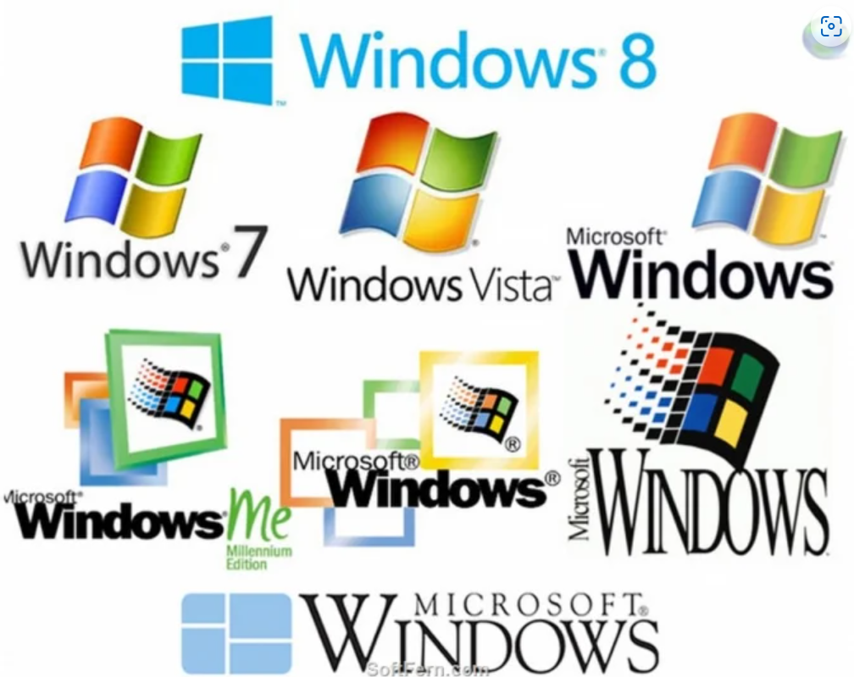  Discuss with learners the evolution of Windows OS, highlighting key features and improvements in each version.  Emphasize the latest version, Windows 11, and its new features.  Explain the role of the taskbar in Windows. Describe its main components: the Start button, taskbar buttons, system tray, and clock.  Demonstrate how to preview windows on the taskbar.  Show how hovering over a taskbar button provides a thumbnail preview of the window, and how clicking on the thumbnail brings the window to the front.  Engage learners to demonstrate and use a computer with Windows OS to show the taskbar features and how to preview windows.  Provide learners with access to computers with Windows OS.  Ask them to explore the taskbar, locate the Start button, open multiple windows, and practice previewing windows by hovering over the taskbar buttons.  For learners who need extra help, provide step-by-step instructions for previewing windows on the taskbar.  Assessment:  - What is an operating system, and why is it important?  - Name three versions of the Windows Operating System.  - What is the latest version of Windows, and name one new feature it includes? |  |  |  |  |  | Computers with Windows OS for demonstration  Screenshots of various Windows OS versions
PHASE 3: REFLECTION | - What are the main components of the taskbar in Windows?  - How can you preview a window on the taskbar?  Use peer discussion and effective questioning to find out from learners what they have learnt during the lesson.  Take feedback from learners and summarize the lesson.

Week Ending: 26-09-2025 |  | DAY: |  | Subject: COMPUTING
Duration: 50mins |  |  |  | Strand: Introduction to computing
Class: B7 |  | Class Size: |  | Sub Strand: Computer Systems
Content Standard:  B7.1.1.2. Demonstrate the use of the features of the Windows Desktop |  |  | Indicator:  B7.1.1.2.2 Explore different user account levels in computer systems |  |  |  | Lesson:  1 of 1
Performance Indicator:  Learners can;  - Identify different user account levels in computer systems.  - Explain the roles and permissions associated with different user account levels.  - Describe the different permission levels for files and folders. |  |  |  |  | Core Competencies:  Communication and Collaboration, Critical Thinking and Problem solving
References: Computing Curriculum Pg.
Keywords: Administrator, Standard User, Guest, Permissions, Access Control
Phase/Duration | Learners Activities |  |  |  |  | Resources
PHASE 1: STARTER | brainstorm learners if they have their own user accounts on the computers they use at home or school. Write their responses on the board.  Show an image of a login screen with multiple user accounts. Ask learners what differences they think might exist between these accounts.
PHASE 2: NEW LEARNING | Introduce the concept of user accounts and explain that there are different levels of accounts with varying permissions and responsibilities.  Provide examples of different user account levels such as Administrator, Standard User, and Guest.  Guide learners to explain the basic differences between these account levels.  - Administrator: Has full control over the system, can install software, change settings, and manage other user accounts.  - Standard User: Can use the computer for everyday tasks but has limited permissions and cannot change system settings or install software without an administrator's approval.  - Guest: Has very limited access, can use the computer for basic tasks but cannot change any settings or access personal files of other users.  Engage learners to discuss the File and Folder Permissions  - Read: Allows the user to view the contents of a file or folder.  - Write: Allows the user to make changes to the contents of a file or folder.  - Execute: Allows the user to run a file or application.  - Full Control: Allows the user to read, write, execute, and change permissions for a file or folder.  Use a computer to show how to view and change permission levels for files and folders.  Demonstrate how to right-click on a file or folder, go to Properties, and navigate to the Security tab to change permissions.  Provide learners with access to computers. Ask them to create a new folder, change its permissions, and add a text file with different permission levels.  Have them experiment with the permissions to see what actions are allowed or restricted.  For learners who need extra help, provide a step-by-step guide on how to change permissions and explain each step clearly.  Assessment  - What is the role of an Administrator account?  - How does a Standard User account differ from an Administrator account?  - What permissions does a Guest account typically have? |  |  |  |  | Computers with user accounts set up for demonstration
PHASE 3: REFLECTION | - What does the "Read" permission allow a user to do with a file or folder?  - How can you change the permissions for a file or folder in Windows?  Use peer discussion and effective questioning to find out from learners what they have learnt during the lesson.  Take feedback from learners and summarize the lesson.

Week Ending: 26-09-2025 |  | DAY: |  | Subject: COMPUTING
Duration: 50mins |  |  |  | Strand: Introduction to computing
Class: B7 |  | Class Size: |  | Sub Strand: Computer Systems
Content Standard:  B7.1.1.2. Demonstrate the use of the features of the Windows Desktop |  |  | Indicator:  B7.1.1.2.2 Practice file management techniques (file & folder management) |  |  |  | Lesson:  1 of 1
Performance Indicator:  Learners can;  - Understand and apply proper file naming conventions.  - Organize files into folders and subfolders effectively.  - Identify different types of file extensions. |  |  |  |  | Core Competencies:  Communication and Collaboration, Critical Thinking and Problem solving
References: Computing Curriculum Pg.
Keywords: Conventions, Folder, Subfolder, File Extension, Organization
Phase/Duration | Learners Activities |  |  |  |  | Resources
PHASE 1: STARTER | Ask learners if they have ever had trouble finding a file on their computer. Discuss the importance of organizing files properly.  Show a messy desktop with files scattered everywhere and a well-organized desktop with files neatly sorted into folders.  Ask learners which one they think is easier to work with and why.
PHASE 2: NEW LEARNING | Introduce the concept of file management and the importance of following naming conventions for files. Explain that naming conventions help keep files organized and easy to find.  Provide examples of good and bad file names  (e.g., "Homework_Math_2024.docx" vs. "Untitled(1).docx").  Discuss why clear and descriptive names are better.  Explain the rules for naming files, such as using descriptive names, avoiding special characters, and including dates or version numbers if necessary.  Discuss the importance of creating folders and subfolders to keep files organized. Show how to create a main folder for a subject (e.g., "Math") and subfolders for different topics or assignments (e.g., "Homework," "Projects").  Explain what file extensions are and why they are important. Provide examples of common file extensions  e.g.,  Use a computer to demonstrate creating folders and subfolders, naming files, and organizing them properly. Show how to view file extensions and explain what each extension signifies.  Provide learners with access to computers.  Ask them to create a main folder for a subject they are currently studying, create subfolders for different topics, and save sample files in these folders using proper naming conventions.  For learners who need extra help, provide a step-by-step guide on creating folders and naming files. Offer one-on-one assistance if necessary.  Assessment  - Why is it important to use clear and descriptive names for files?  - What are two rules you should follow when naming a file?  - Explain the purpose of a folder and a subfolder. |  |  |  |  | Computers for demonstration and student use  Screenshots of file management examples
  .docx | - | Microsoft word document
  .pdf | - | Portable document format
  .jpg | - | JPEG image
  .png | - | Portable network graphics image
  .mp3 | - | Audio files
  .mp4 | - | Video files
  .avi | - | Audio video interface video file
  .zip | - | Compressed achive file
  .exe | - | Executable file
  .xlsx | - | Microsoft excel spreadsheet
  .html | - | Hypertext markup language file
PHASE 3: REFLECTION | - What is a file extension, and why is it important?  - Give an example of a file extension and the type of file it represents.  Use peer discussion and effective questioning to find out from learners what they have learnt during the lesson.  Take feedback from learners and summarize the lesson.

